|  |  |  |  |  |  |
| --- | --- | --- | --- | --- | --- |
| Date | 8-Dec-22 | | | Tester Name | Shahabuddin Syed |
| Environment | Penfax - Test | | | Login used |  |
| Operating System | Windows | Version: | Update: | | |
| Software Used | Edge | Version: | Update: | | |
| Select Software | Version: | Update: | | |
| Release version |  | | | | |
| Title | E24.04 CRA Tax Updates for dynamic calculation of TD1 basic claim amount based on code for NS, FD, and YT | | | | |
| Test Type | Regression | | | | |
| Test Scenario | CRA Tax Updates for dynamic calculation of TD1 basic claim amount based on code for NS, FD, and YT | | | | |
|  |  | | | | |
| Expected Results |  | | | | |
| Pass/Fail | Select | | | JIRA# | N/A |

Describe your steps with screenshots:

SID: 254263

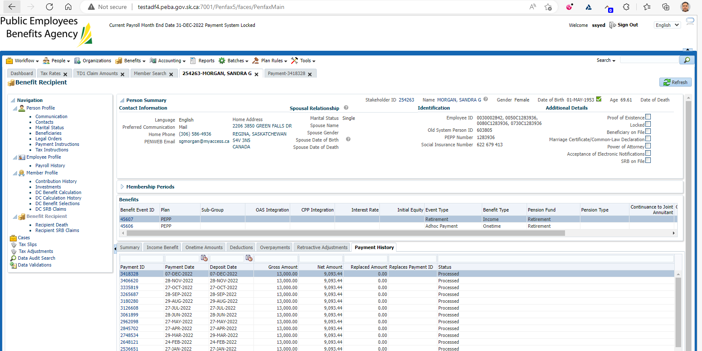

Federal dynamic BPA

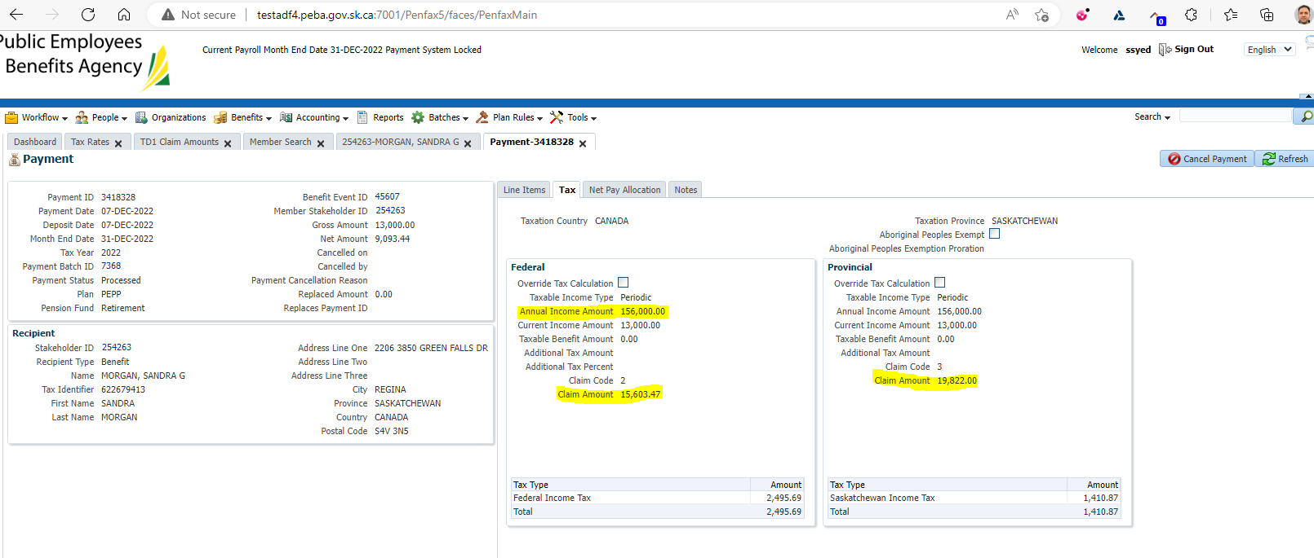

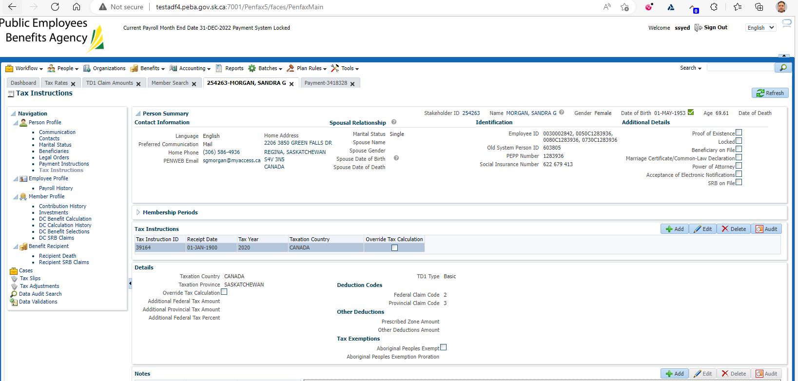

Federal claim codes were inputted last in 2020 and no longer used

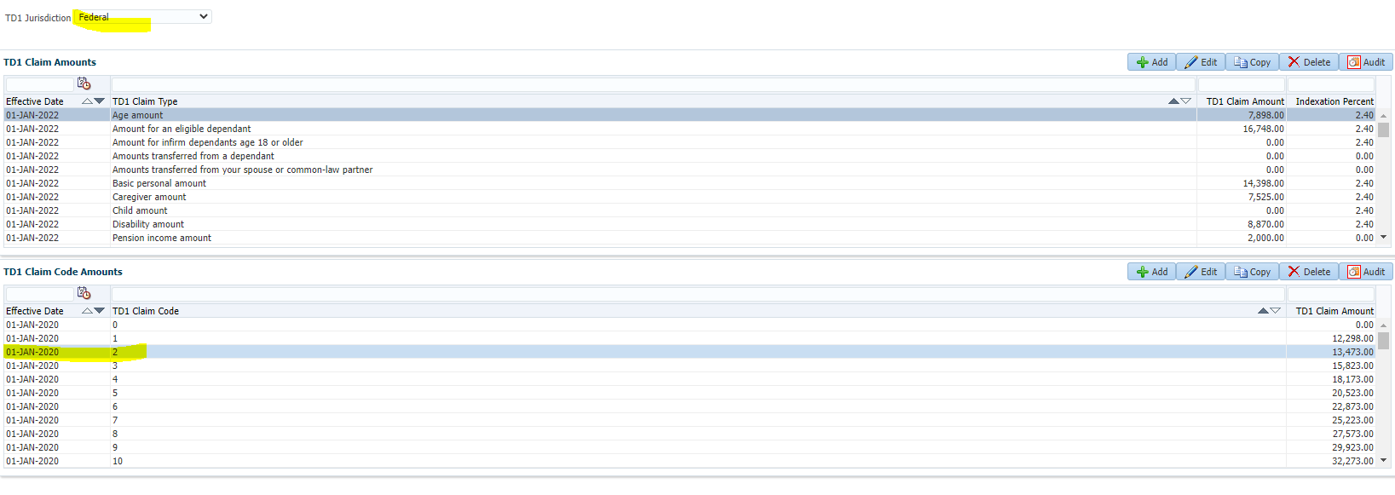

Dynamic calc formulas to be used- Refer procedure kept here H:\Quality Assurance\Prod Apps\QA Procedures\ How to calculate Claim amount on payment screen.docx

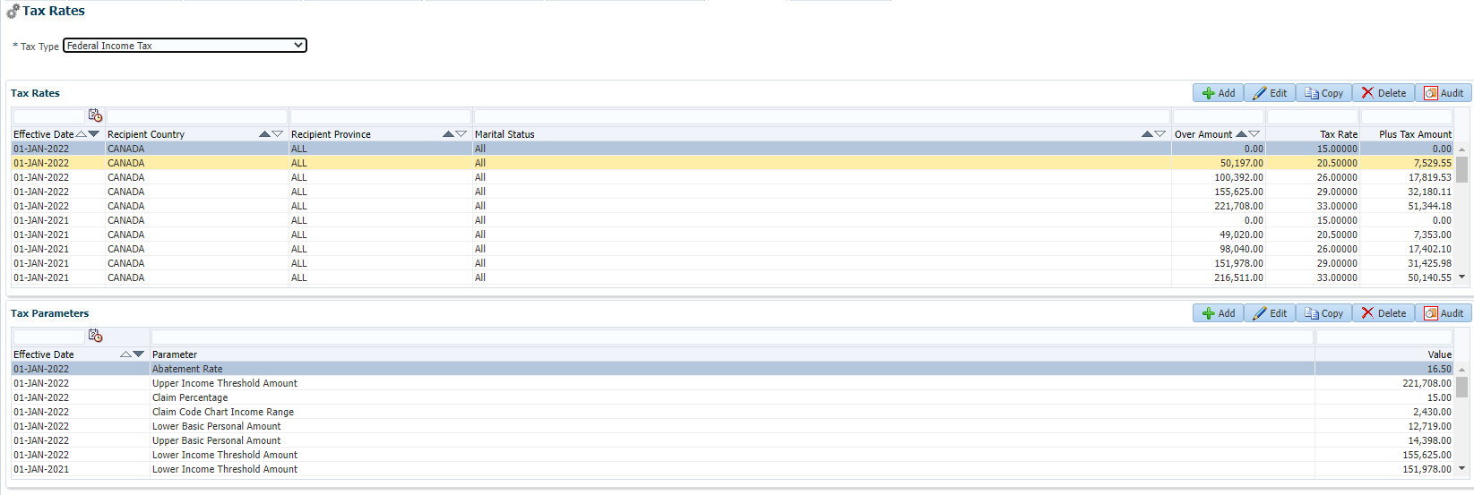

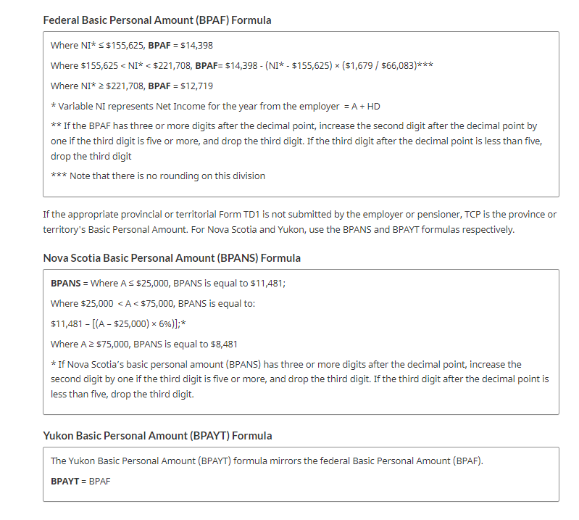

BPA= 14398- (156000-155625) * (1679/66083) = 14,388.47

Federal Claim amount for claim code 2= BPA (1) + 2430/2 (2) = 15,603.47 (matching)

